FODS Lab Practice Questions
Name:.M.Nandhini
Reg.no:192472318

- Student Subject Averages using NumPy
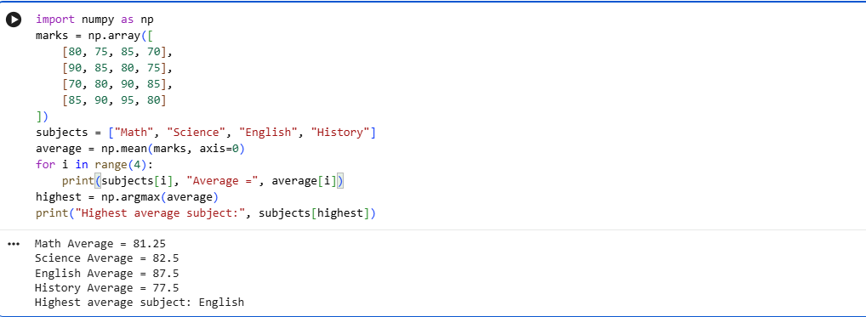
- Average Product Price using NumPy
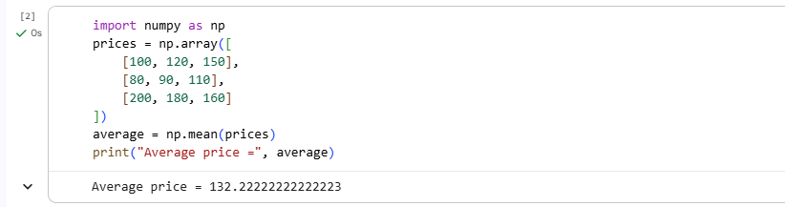
- Average Sale Price of Houses with More Than 4 Bedrooms
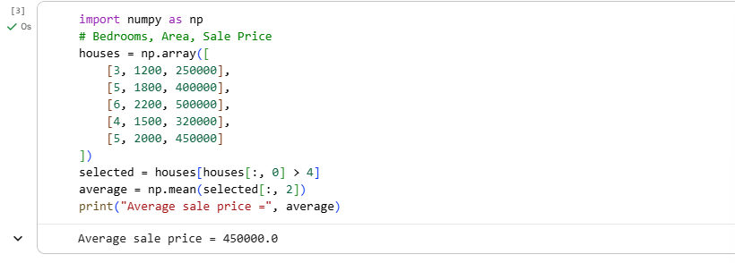
- Total Yearly Sales and Percentage Increase
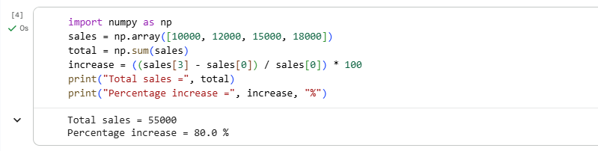
- Average Fuel Efficiency and Percentage Improvement
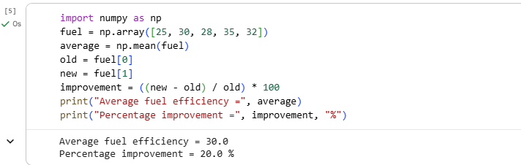
- Total Grocery Cost with Discount and Tax
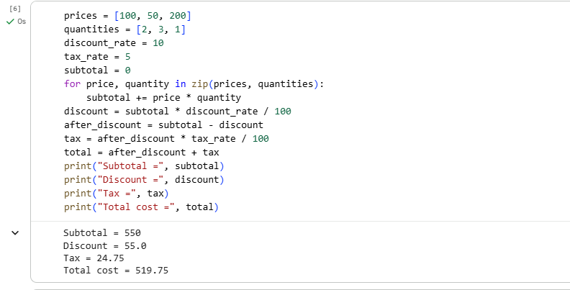
- Pandas Order Analysis
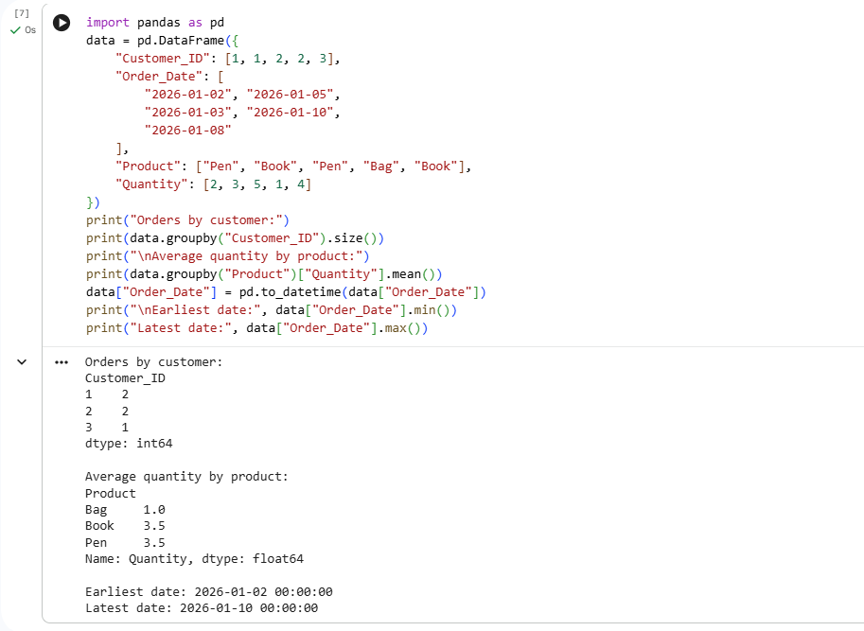
- Top 5 Products Sold
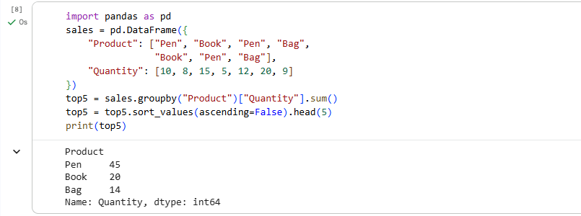
- Property Data Analysis using Pandas
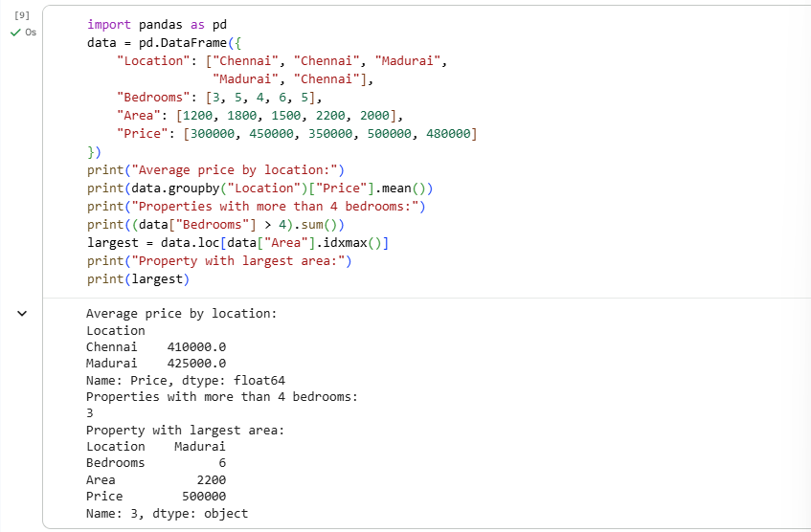
- Monthly Sales – Line Plot and Bar Plot
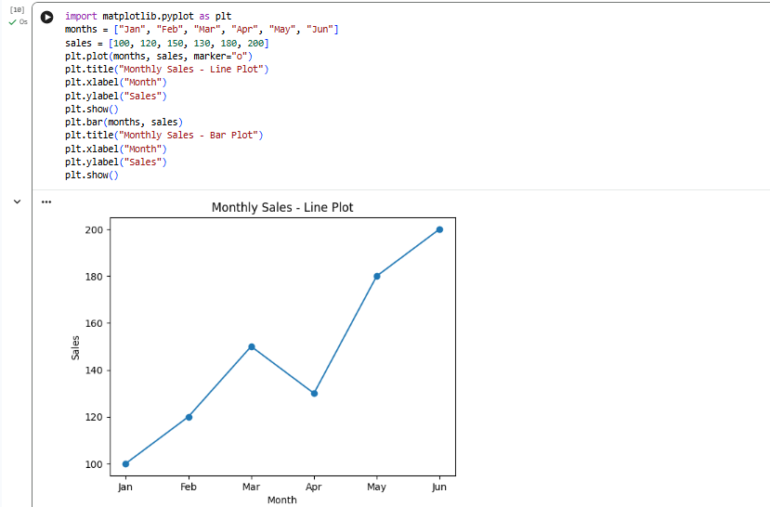
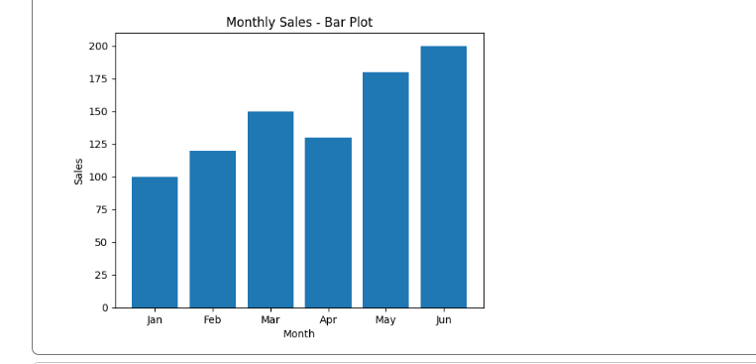
- Sales over Time – Line, Scatter and Bar Plots
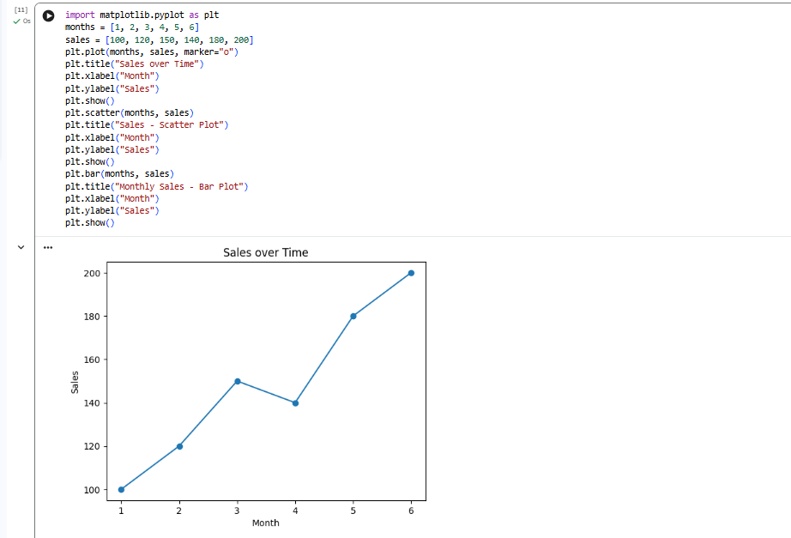
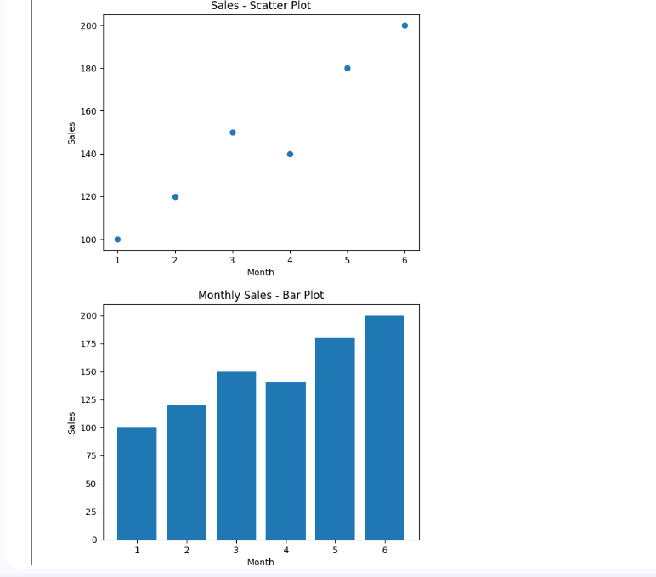
- Monthly Temperature and Rainfall Plots
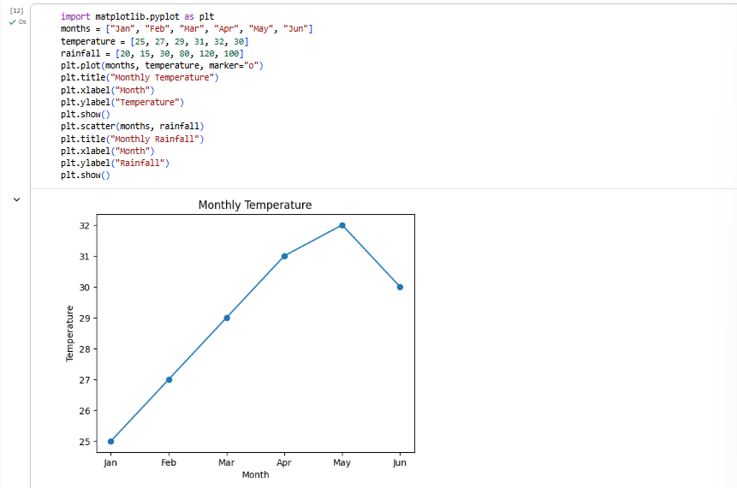
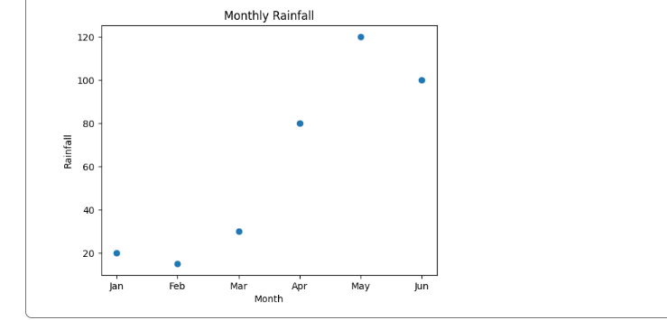
- Word Frequency from a Text File
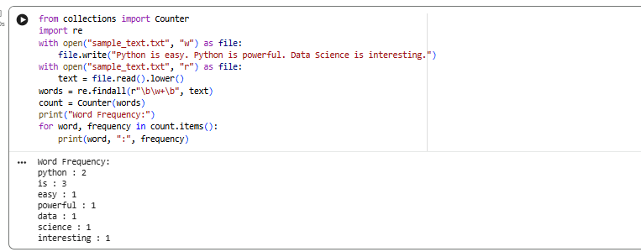
- Frequency Distribution of Customer Ages
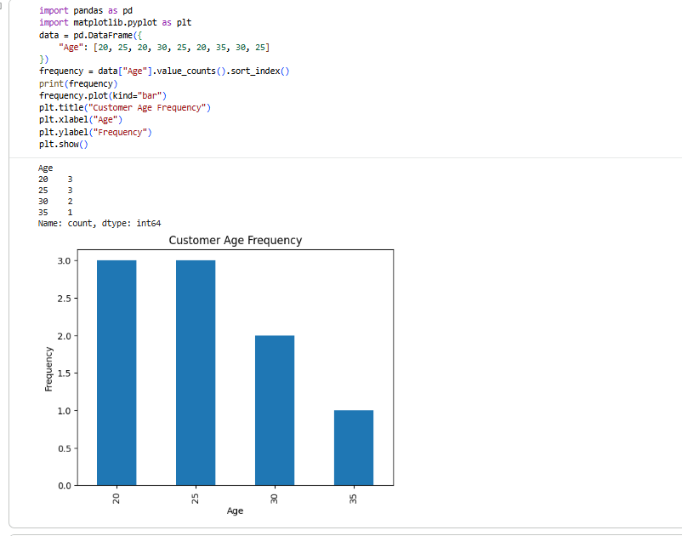
- Frequency Distribution of Likes
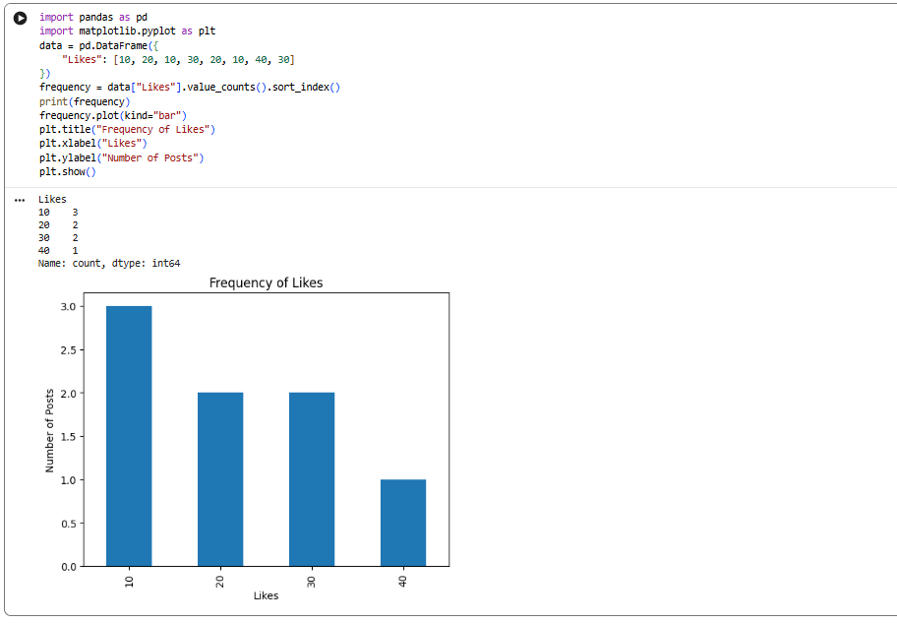
- Word Frequency in Customer Reviews
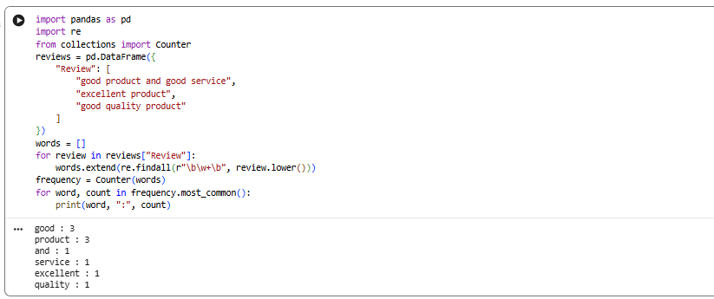
- Customer Feedback – Top N Word Frequency
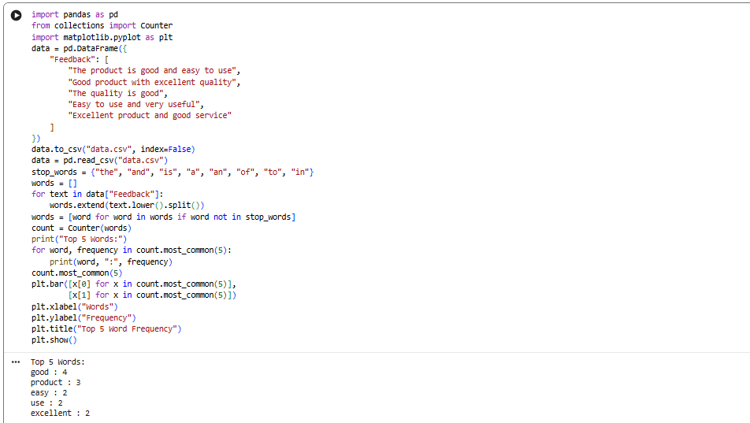
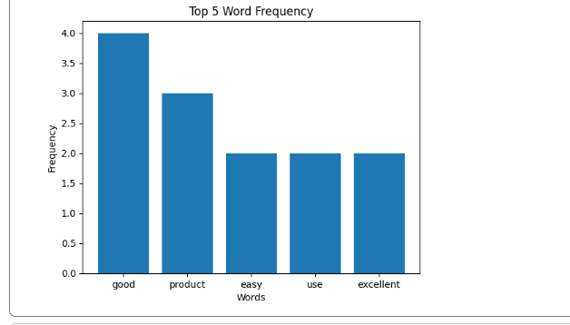
- Mean, Median, Standard Deviation, Boxplot, Scatter Plot and Q-Q Plot
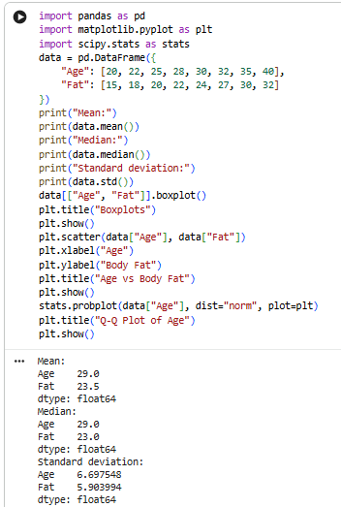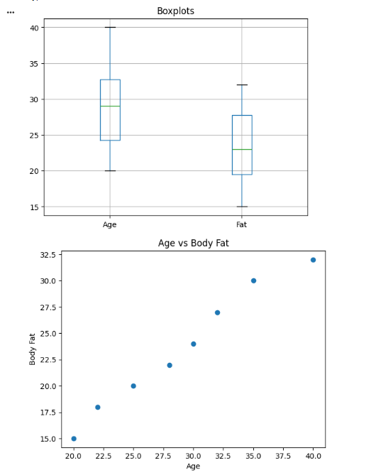
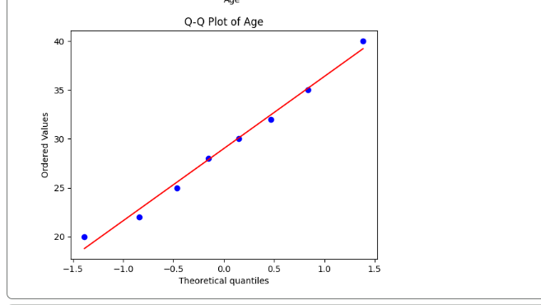
- 95% Confidence Interval for Blood Pressure Reduction
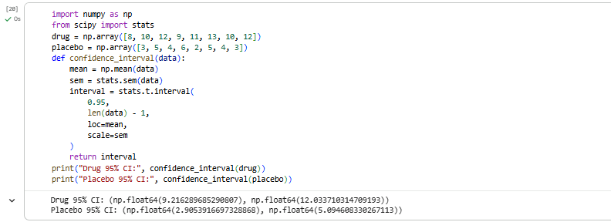
- A/B Test – Compare Two Conversion Rate Samples
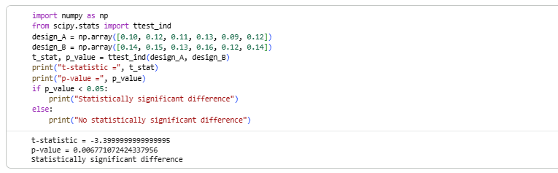
- Point Estimate and Confidence Interval from CSV
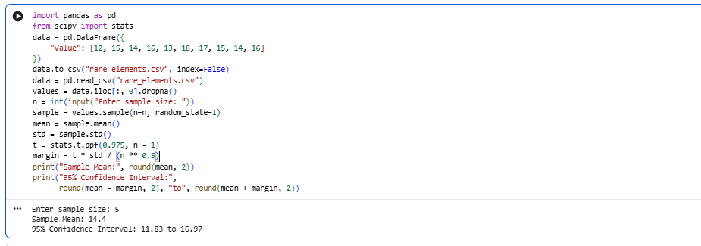
- Confidence Interval for Mean Customer Rating
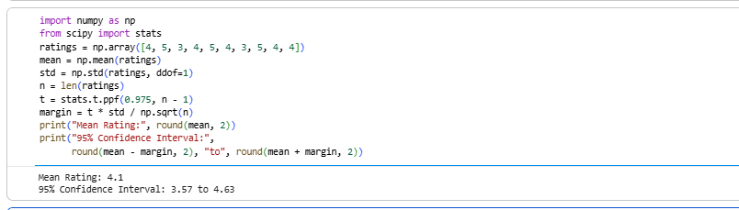

- Hypothesis Testing for Treatment vs Placebo
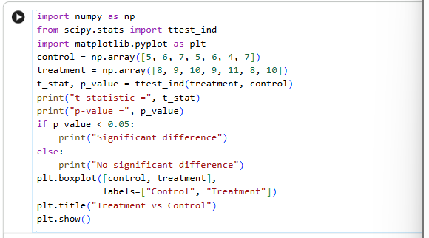
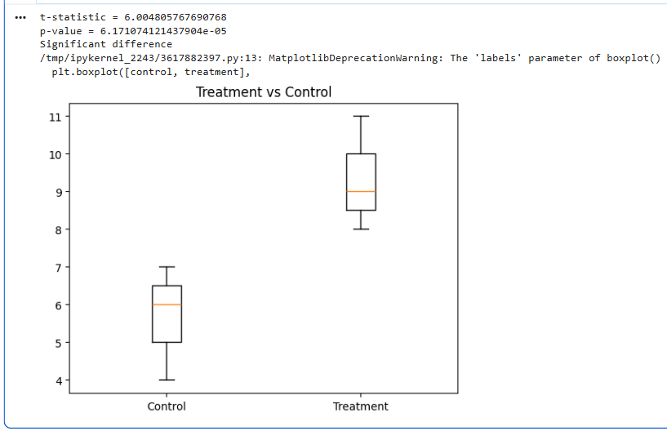
- KNN Classifier for a New Patient
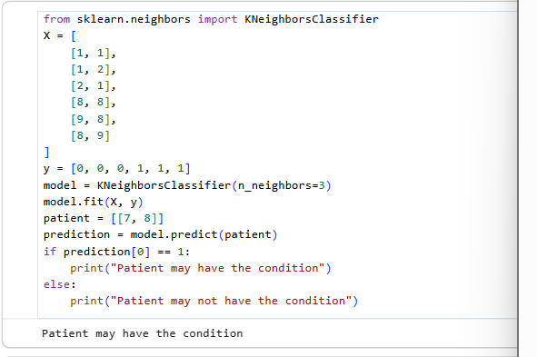
- Decision Tree for Iris Classification
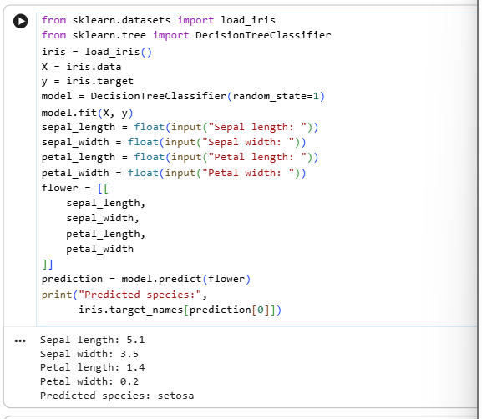
- Linear Regression for Housing Price Prediction
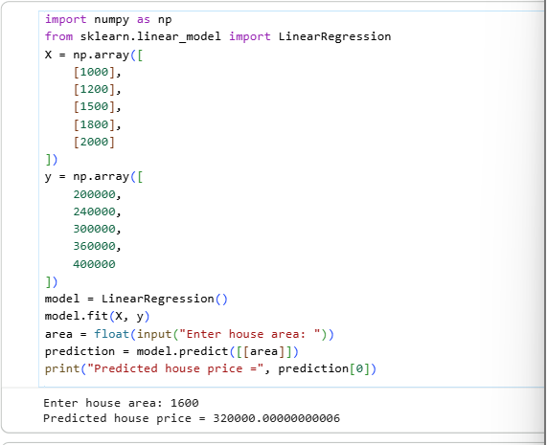
- Logistic Regression for Customer Churn
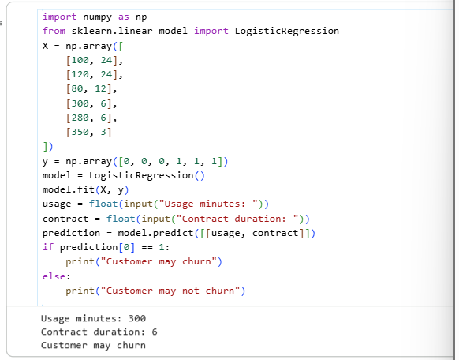
- K-Means Customer Segmentation
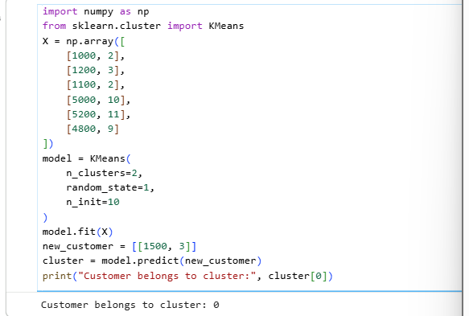
- Accuracy, Precision, Recall and F1-Score
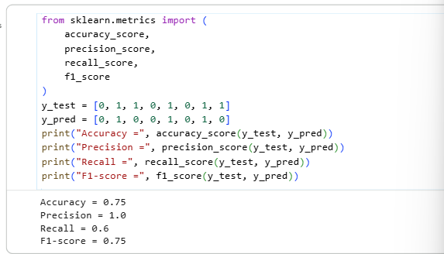
- CART Regression for Used Car Price
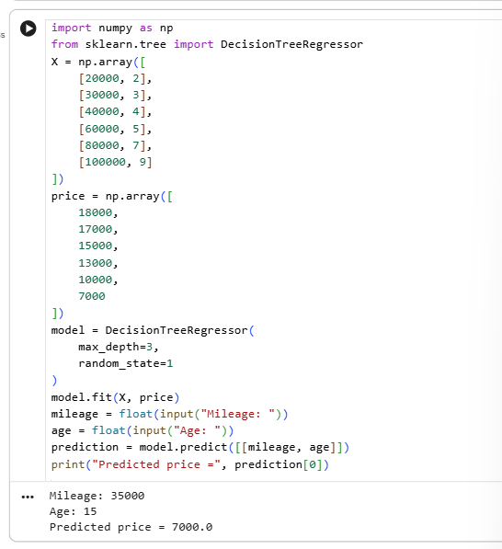
- Customer Segmentation using K-Means
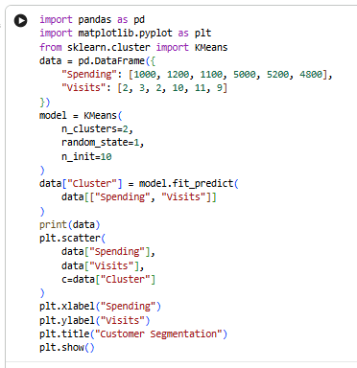
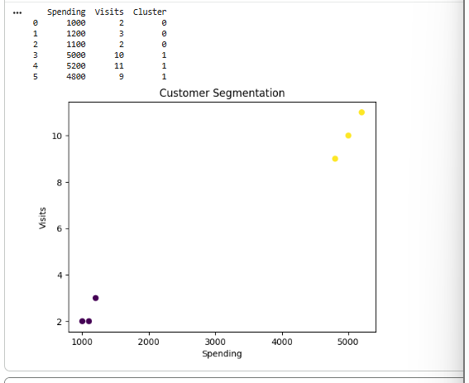
- Bivariate Analysis and Linear Regression for House Price
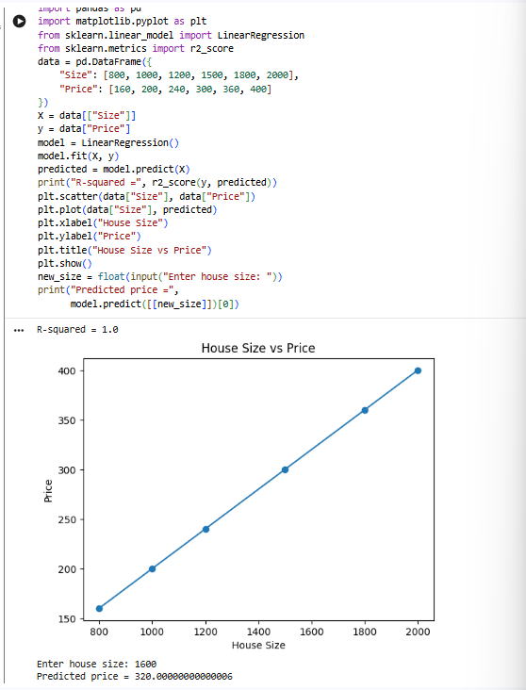
- Multiple Linear Regression for Car Price
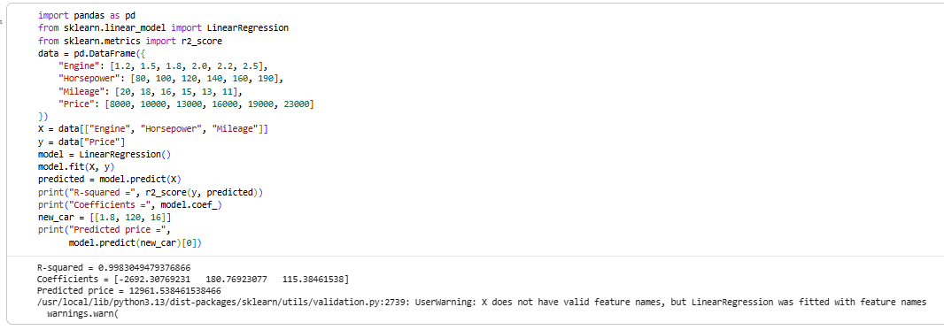
- KNN Classification with Evaluation Metrics
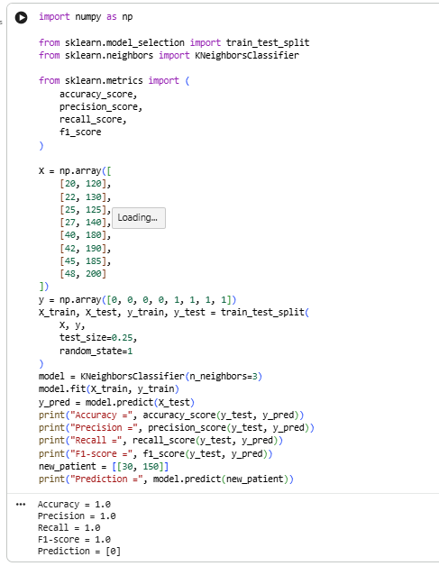
- K-Means Clustering for Retail Customers
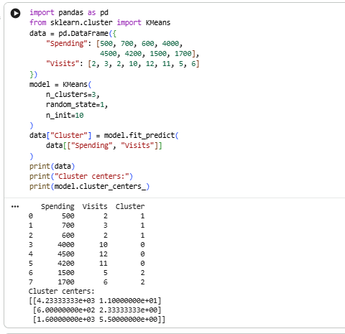
- Stock Price Variability from CSV
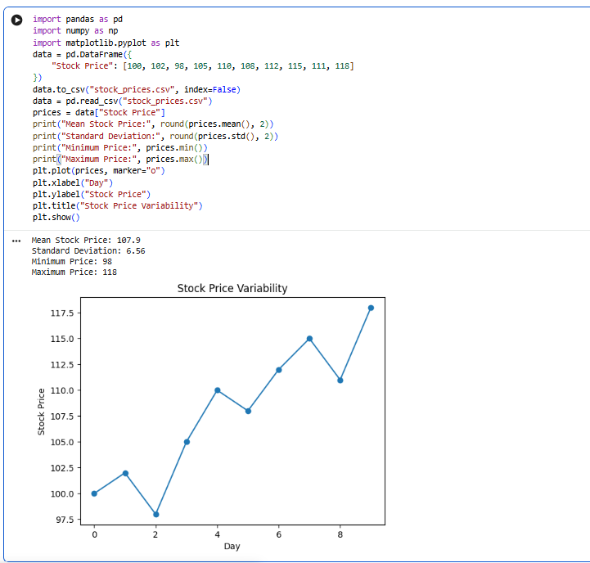
- Correlation between Study Time and Exam Score
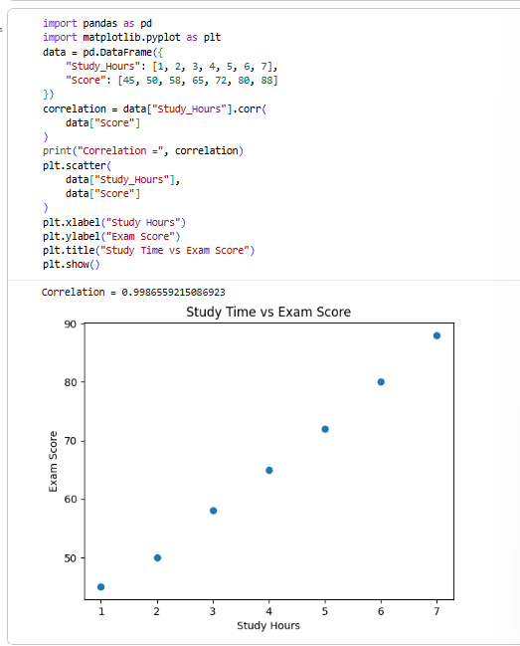
- Temperature Analysis for Different Cities
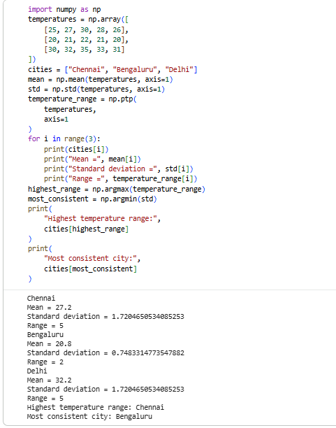
- K-Means Clustering and Visualization
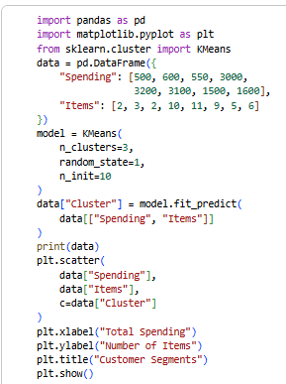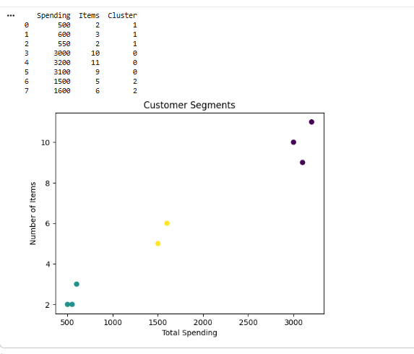
- Soccer Player Analysis using Pandas
